**In depth on the Fox class.**

**Run() is the method which makes Rabbits do what they do. Hunt() is the method for foxes. Here they are side by side.**

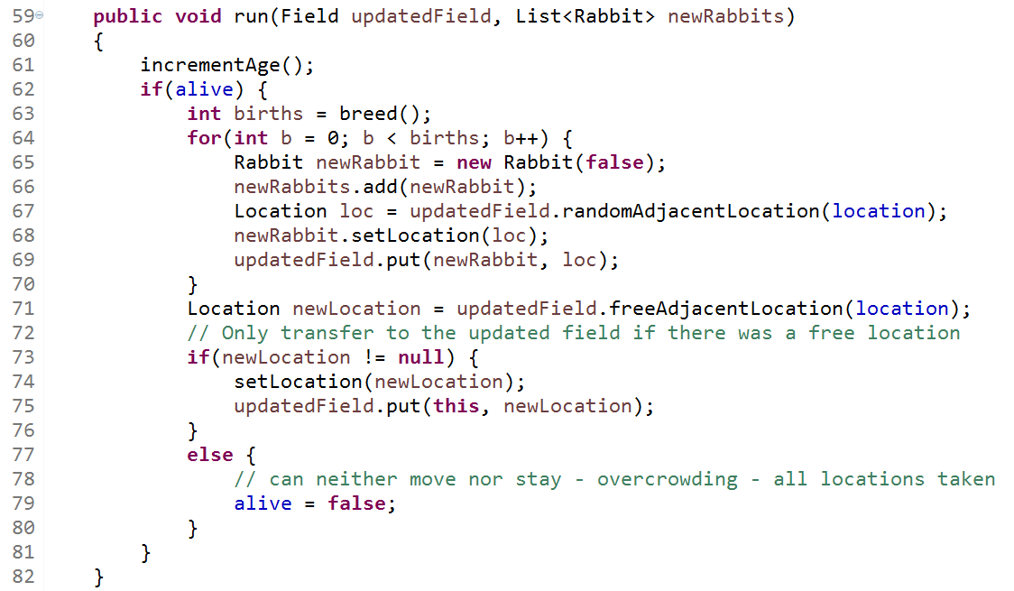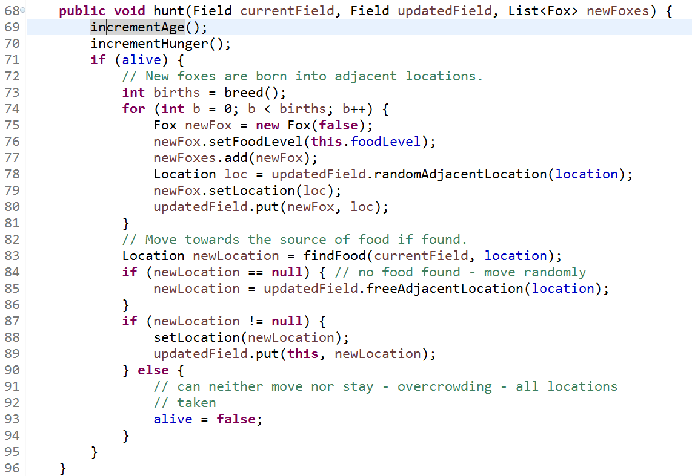(1). Underline every line in hunt() which does something that doesn’t happen in run(); (In other words, what lines in hunt() do something unique to foxes?)

(2). Notice that hunt() takes **three** inputs, and run only has 2. The unique input to hunt() is the **current** field (which all the animals are on). Why do rabbits not need to know what the current field looks like, but foxes do? [what’s something that only foxes do which might make them need that information?]

(3). a). Underline the methods ***randomAdjacentLocation*** and ***freeAdjacentLocation*** in hunt(). “adjacent” means “next to”. One of these is for the location of the baby Fox and one is for the location of the parent fox. Which is which?

b). Underline the **findFood** method in hunt(). It returns a Location object. What does that location represent?